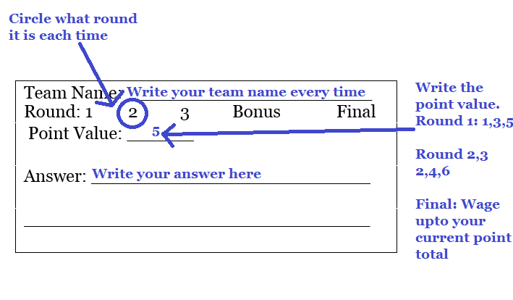
Use the following to work out the questions used in team trivia.

Round 1, Question 1

Round 1, Question 2

Round 1, Question 3

Round 2, Question 1

Round 2, Question 2

Round 2, Question 3

Bonus

Round 3, Question 1

Round 3, Question 2

Round 3, Question 3

Final Question

