Parabola Match
This Parabola Match was designed and created by Shirlee-Anne Campbell and Laurie Callbeck--
grade 11 math teachers at Three Oaks Senior High. The images you see can be downloaded as WordPerfect 9.0 files.
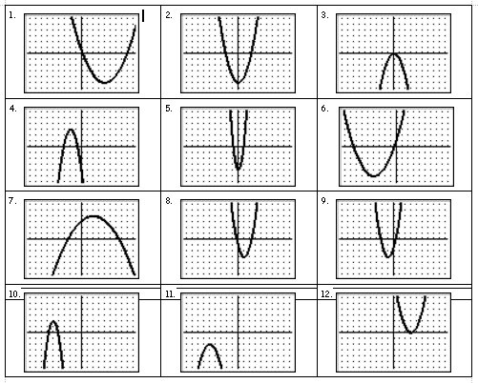
How does the match work?
Copy each of the four files unto coloured sheets of paper -- one colour for the graph, one for the equation, one for the vertex and yet another for the axis of symmetry. Cut sheets into rectangles to create cards. Have students match various components of the parabola together (for example: match the equation with the vertex). As an end result, have students match all four cards together (match the graph with the vertex and the axis of symmetry and the equation). Please note, that cards are not in a 1:1:1:1 ratio which means that card 1, card I, card a, and card A are not necessarily a match. This can help the teacher save time in that the students can cut the cards out without knowing the answers.

