Question 1

Find the x-intercept and the y-intercept of the graph.

4x – 8y = 24

Answer A

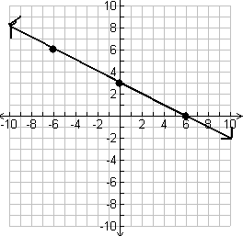
Question 2

Find the x-intercept and the y-intercept of the graph.

3x – 2y = -6

Answer B

x-intercept: 4

y-intercept: 5

Question 3

Find the x-intercept and the y-intercept of the graph.

y = 5x – 13

Answer C

x-intercept: 6

y-intercept: -3

Question 4

Find the x-intercept and the y-intercept of the graph.

y = 2.5x + 10

Answer D

x-intercept: -2

y-intercept: 5

Question 5

Identify the x-intercept and the y-intercept of the graph.

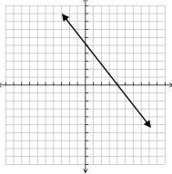
Answer E

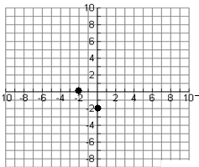

Question 6

Identify the x-intercept and the y-intercept of the graph.

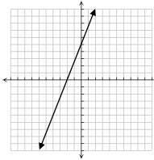
Answer F

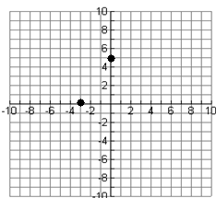
Question 7

Identify the x-intercept and the y-intercept of the graph.

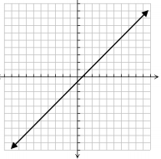
Answer G

x-intercept: -4

y-intercept: 10

Question 8

Identify the x-intercept and the y-intercept of the graph.

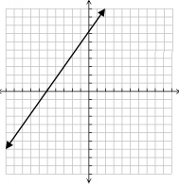
Answer H

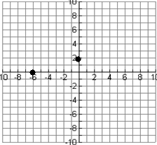

Question 9

Graph the function.

2x + 4y = 12

Answer I

x-intercept: -5

y-intercept: 7

Question 10

Graph the function.

-5x + 3y = 15

Answer J

x-intercept:-2

y-intercept: 3

Question 11

Graph the function.

-4x – 4y = 8

Answer K

x-intercept: 13/5

y-intercept: -13

Question 12

Graph the function.

-x + 3y = 6

Answer L

x-intercept: 1

y-intercept: -2/3

