**Group Members:**

_________________________________

_________________________________

_________________________________

_________________________________

Create a double-loop to wrap around Barbie’s feet. A double-loop is made by securing one rubber band to another with a slip knot, as shown (below left).

Use the Venn-Diagram Method.



Wrap the open end of the double-loop tightly around Barbie’s feet, as shown.



Attach a second rubber band to the first one, again using a slip knot, as shown below.



With two rubber bands now attached, hold the end of the rubber bands at the jump line with one hand, and drop Barbie from the line with the other hand. Have a partner make a mark to the lowest point that Barbie reaches on this jump.

Measure the jump distance in centimeters, and record the value in the data table below. You may wish to repeat this jump several times and take the average, to ensure accuracy. Accuracy is important—Barbie’s life could depend on it!

Repeatedly attach two additional rubber bands for each new jump, measure the jump distance, and record the results in the data table.

**Complete the data table below**

|  |  |
| --- | --- |
| **NUMBER OF**  **RUBBER BANDS (*x*) $$L_{1}$$** | **JUMP DISTANCE IN**  **CENTIMETERS (*y*) $$L_{2}$$** |
| **2** |  |
| **3** |  |
| **4** |  |
| **5** |  |
| **6** |  |
| **7** |  |

**Prepared By: ________________________ and __________________________**

**Method 1: Line of Best Fit using a Graphing Calculator**

1. Sketch your scatter plot in the blank rectangle.

$$L_{1}=\# of rubber bands$$

$$L_{2}=distance Barbie fell in centimeters$$

What type of correlation does the data show? ________________________________________

1. Find the line of best fit for the data. Sketch your line in your picture, and fill out the information below:

a = ___________________________________

b = ___________________________________

r = ___________________________________

1. Round the values for *a* and *b* to the nearest hundredth, and write the equation of your line of best fit.

__________________________

1. Use you equation to predict the number of rubber bands (*x*) that will be needed for the Barbie to safely fall 590 cm. Will substitute in 590 for *y* and solve for *x*.

**Prepared By: ________________________ and __________________________**

**Method 2: Line of Best Fit by Hand**

1. Make a scatter plot of your data. Indicate the scale on each axis.

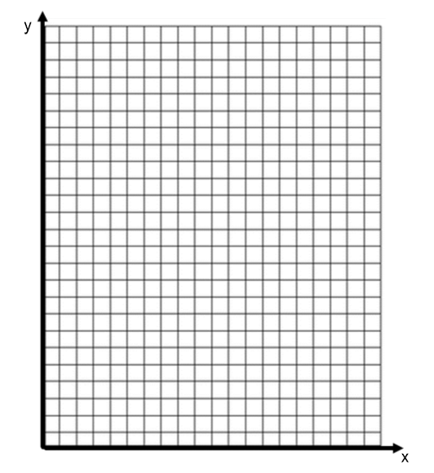

1. On the graph above, sketch a line of best fit.
2. Write the equation of your line.
3. Find slope (algebraically or graphically)
4. y-intercept (algebraically or graphically if clearly visible)
5. Equation of the line (in slope-intercept form)
6. Use you equation to predict the number of rubber bands (*x*) that will be needed for the Barbie to safely fall 590 cm. Will substitute in 590 for *y* and solve for *x*.

**Whole Group—Pre-Launch**

1. Which line of best fit does your group plan on using to make the prediction? Why?
2. Based on your data, what would you predict is the maximum number of rubber bands so that Barbie could safely jump 590 cm? If you equation had a decimal, would you round up or down in this situation?
3. Are your predictions reliable? Justify your answer. Be sure to consider your methods of collecting, recording, and plotting data.

**Whole Group—Post-Launch**

1. Did your Barbie die? How did you tell?
2. What would you do differently next time? Would you add, subtract rubber bands?
3. What do you think would happen if you launched your Barbie with the same number of rubber bands tomorrow?