Name: _________________________________ Period: _________
GPS Advanced Algebra Unit 4 Wednesday, January 16, 2012

____1. Which one of the following functions is even?
A. f(x) = x⁴ + x³
B. g(x) = x⁴ + x²
C. h(x) = x⁵ + x³
D. k(x) = x³ + x

____2. Which one of the following functions is odd?
A. f(x) = 3x⁴ - 4x³
B. g(x) = 5x⁴ + 3x²
C. h(x) = 6x⁵ - x³
D. k(x) = x⁶ + 8x²

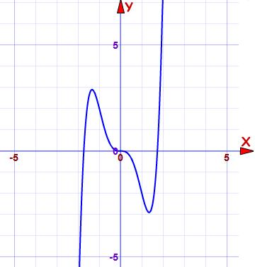
____3. The function shown in the graph is:
A. Even
B. Odd
C. Neither even nor odd
D. Both even and odd

Name: _________________________________ Period: _________
GPS Advanced Algebra Unit 4 Wednesday, January 16, 2012

____1. Which one of the following functions is even?
A. f(x) = x⁴ + x³
B. g(x) = x⁴ + x²
C. h(x) = x⁵ + x³
D. k(x) = x³ + x

____2. Which one of the following functions is odd?
A. f(x) = 3x⁴ - 4x³
B. g(x) = 5x⁴ + 3x²
C. h(x) = 6x⁵ - x³
D. k(x) = x⁶ + 8x²

____3. The function shown in the graph is:
A. Even
B. Odd
C. Neither even nor odd
D. Both even and odd

____4. The function shown in the graph is:
A. Even
B. Odd
C. Neither even nor odd
D. Both even and odd
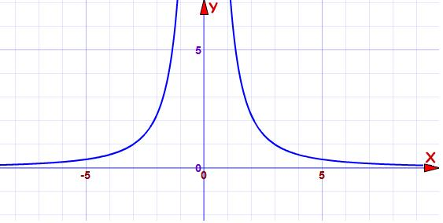

___5. The function shown in the graph is:
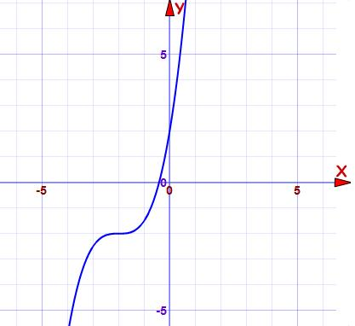
A. Even
B. Odd
C. Neither even nor odd
D. Both even and odd

____4. The function shown in the graph is:
A. Even
B. Odd
C. Neither even nor odd
D. Both even and odd

___5. The function shown in the graph is:
A. Even
B. Odd
C. Neither even nor odd
D. Both even and odd

