**Objective**: To identify if a function is even, odd, or neither

**Link to article read in class:** <http://www.bbc.co.uk/news/magazine-20559052>

**Tell whether the function is even, odd, or neither.**

|  |  |  |  |
| --- | --- | --- | --- |
|  | **Algebraically** | | **Graphically** |
| **Function** | **When…** | **The exponents are…** | **Graph is symmetric about…** |
| Even | $$f\left(-x\right)=f(x)$$ |  |  |
| Odd | $$f\left(-x\right)=-f(x)$$ |  |  |
| Neither | Neither even or odd |  |  |

***Beware of constants:*** *All constants really have a ____________ and zero is ____________.*

**Determine if the following are even, odd, or neither.**

$f\left(x\right)=x^{3}-x$

$f\left(x\right)=x^{2}+1$

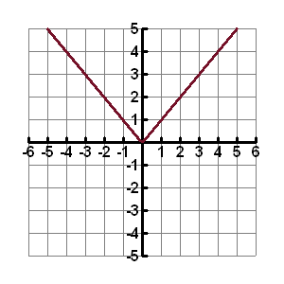

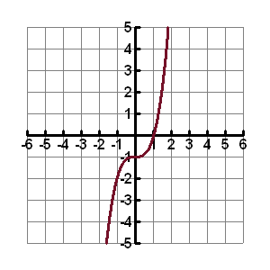

5a. $f\left(x\right)=2x^{4}-3$ 5b. $f\left(x\right)=x^{3}+x$

6a. $f\left(x\right)=-x^{3}$

6b. $f\left(x\right)=5x^{3}$

6c. $f\left(x\right)=x^{2}+4$

7a. $f\left(x\right)=x^{3}-x^{2}$

7b. $f\left(x\right)=-x^{3}+2x$

7c. $f\left(x\right)=x^{3}+4x+1$

8a.

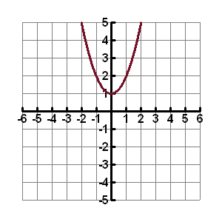

8b.

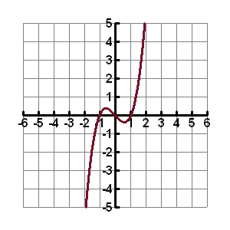

9a.

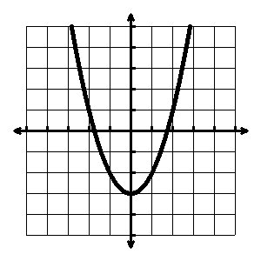

9b.

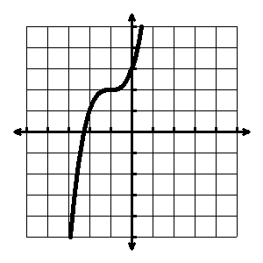

9c.

