GPS Advanced Algebra Unit 4

**Objective**: To identify end behavior of polynomial functions algebraically and graphically.

|  |  |  |  |
| --- | --- | --- | --- |
| **Degree of Polynomial** | **Leading Coefficient** | **Graphically** | **Description** |
| **Even** | **Positive** |  | **as** |
| **Even** | **Negative** |  | **as** |
| **Odd** | **Positive** |  | **as**  **as** |
| **Odd** | **Negative** |  | **as**  **as** |

**Describe the degree and leading coefficient of the polynomial function. Then describe the end behavior of the graph.**

1) 

The degree is _________ and the leading coefficient is _________.

**______ as **

**______ as **

2) 

The degree is _________ and the leading coefficient is _________.

**______ as **

**______ as **

3) 

The degree is _________ and the leading coefficient is _________.

**______ as **

**______ as **

4) 

The degree is _________ and the leading coefficient is _________.

**______ as **

**______ as **

**Describe the end behavior of the graph. Then describe the degree and leading coefficient of the polynomial function.**

5)

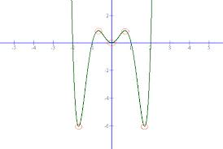

**______ as **

**______ as **

The degree is _________ and the leading coefficient is _________.

6)

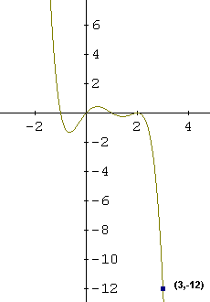

**______ as **

**______ as **

The degree is _________ and the leading coefficient is _________.

7)

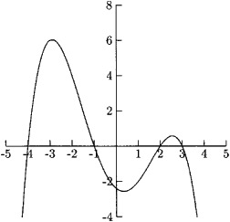

**______ as **

**______ as **

The degree is _________ and the leading coefficient is _________.

8)

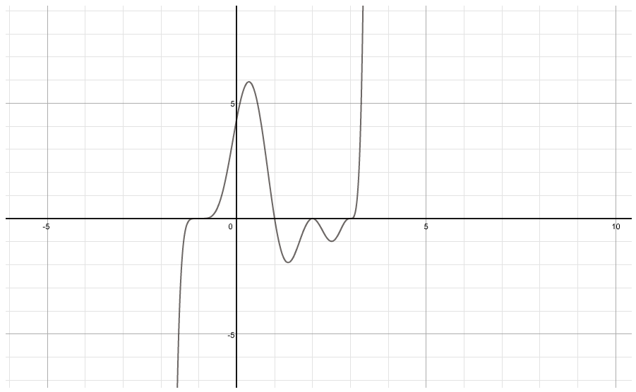

**______ as **

**______ as **

The degree is _________ and the leading coefficient is ________.

**Use what you know about end behavior to match the polynomial function with its graph.**

9) 

10) 

11) 

