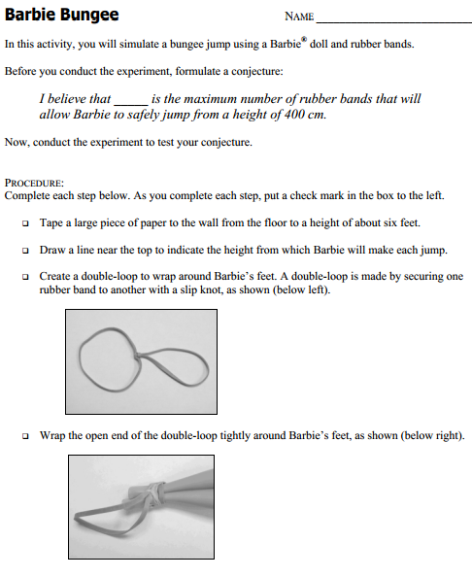

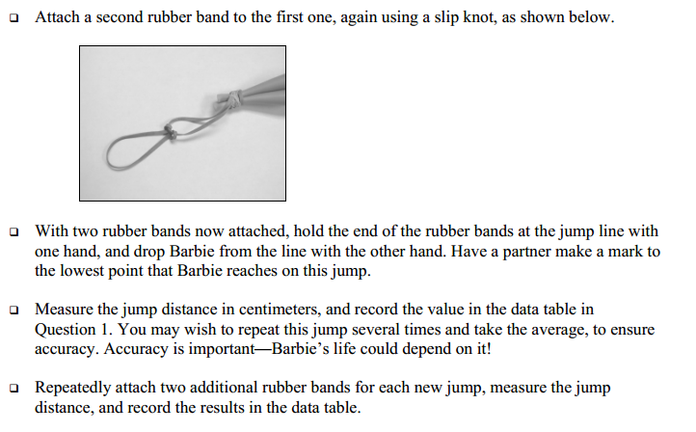

Complete the data table below.

Number of Rubber Bands (x) | Jump Distance in Centimeters (y)
2
4
6
8
10
12

Complete the data table below.

Number of Rubber Bands (x) | Jump Distance in Centimeters (y)
2
4
6
8
10
12

