Math 3 Support

Monday, April 9, 2012

**Objective**: Use the Binomial Theorem to expand binomials

**Pascal’s Triangle**

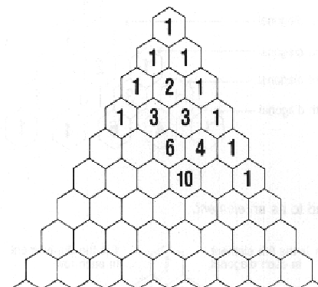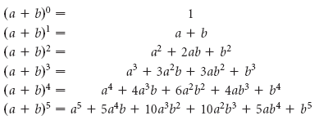

**Binomial Theorem:** The relationship between Pascal’s Triangle

and the coefficients of the terms in the expansion of powers of .

**Expand the following by using the Binomial Theorem and Pascal’s Triangle:**









1.



2. 

3. 

**4.** 

**5.** 

**6.** 

**7.** 

**8.** 

**9.** 