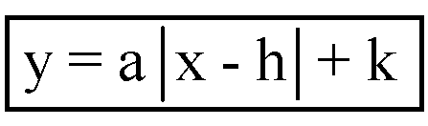
GPS Algebra
Lesson 2.4 Day 2
Purple Book
Standard: MM2A1b

Objective: To write the equations of absolute value functions.

Steps:
1st: Find the vertex Sub x in for h and k in for y
2nd: Find another point on the graph and sub in the equation with h and k this is the a value
3rd: Write the equation with a, h, and k

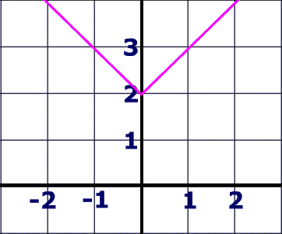  1st:  Vertex: _______ h = _____, k = ______  2nd:  3rd:  Equation: _______________________ | 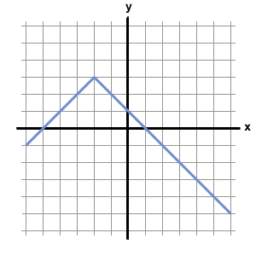  1st:  Vertex: _______ h = ______, k = _______  2nd:  3rd:  Equation: _______________________ | 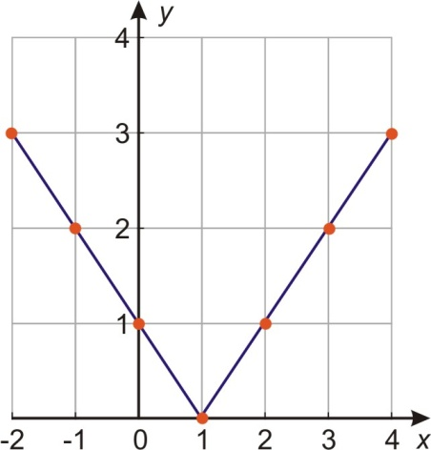  1st:  Vertex: _______ h = _____, k = _____  2nd:  3rd:  Equation: _______________________
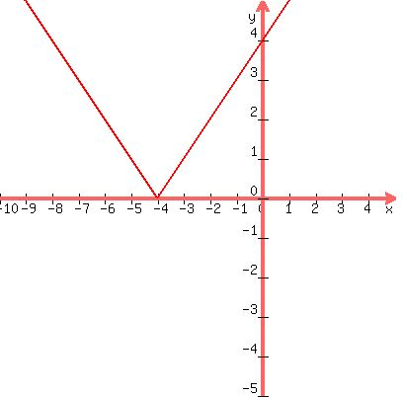 | 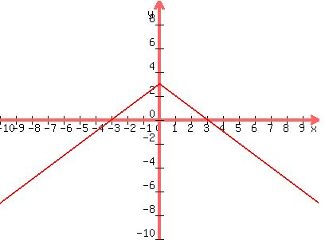 | 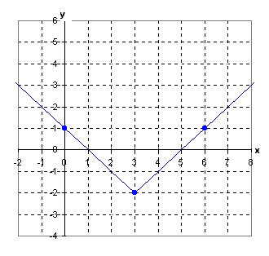
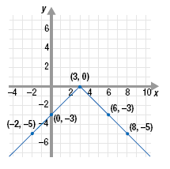

HW: Pg 42 #17-21 and Pg 44 #10-12, 19-21 and Quiz #14 (2.2 and 2.4) on Wednesday!!!

